Comparison between different Cloud Initiative

By Muskan Rajpal

Introduction

This report will help you understand different about Cloud Computing, Cloud platforms with respect to their availability, speed, easy to access, popularity, and some other features.

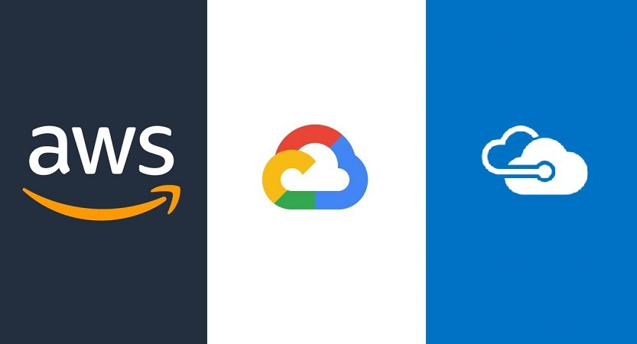

What is Cloud Computing ?

Cloud computing is the delivery of different services through the Internet. These resources include tools and applications like data storage, servers, databases, networking, and software.

Rather than keeping files on a proprietary hard drive or local storage device, cloud-based storage makes it possible to save them to a remote database. As long as an electronic device has access to the web, it has access to the data and the software programs to run it.

Cloud computing is a popular option for people and businesses for a number of reasons including cost savings, increased productivity, speed and efficiency, performance, and security.

[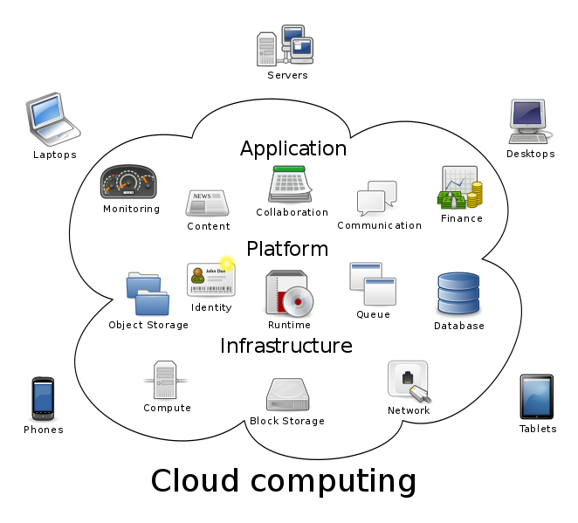](https://upload.wikimedia.org/wikipedia/commons/b/b5/Cloud_computing.svg)

Benefits of cloud computing

Cloud computing offers your business many benefits. It allows you to set up what is essentially a virtual office to give you the flexibility of connecting to your business anywhere, any time. With the growing number of web-enabled devices used in today's business environment (e.g. smartphones, tablets), access to your data is even easier.

There are many benefits to moving your business to the cloud:

**Reduced IT costs**

Moving to cloud computing may reduce the cost of managing and maintaining your IT systems. Rather than purchasing expensive systems and equipment for your business, you can reduce your costs by using the resources of your cloud computing service provider. You may be able to reduce your operating costs because:

* the cost of system upgrades, new hardware and software may be included in your contract
* you no longer need to pay wages for expert staff
* your energy consumption costs may be reduced
* there are fewer time delays.

**Scalability**

Your business can scale up or scale down your operation and storage needs quickly to suit your situation, allowing flexibility as your needs change. Rather than purchasing and installing expensive upgrades yourself, your cloud computer service provider can handle this for you. Using the cloud frees up your time so you can get on with running your business.

**Business continuity**

Protecting your data and systems is an important part of [business continuity planning](https://www.business.qld.gov.au/running-business/protecting-business/risk-management/continuity-planning). Whether you experience a natural disaster, power failure or other crisis, having your data stored in the cloud ensures it is backed up and protected in a secure and safe location. Being able to access your data again quickly allows you to conduct business as usual, minimising any downtime and loss of productivity.

**Collaboration efficiency**

Collaboration in a cloud environment gives your business the ability to communicate and share more easily outside of the traditional methods. If you are working on a project across different locations, you could use cloud computing to give employees, contractors and third parties access to the same files. You could also choose a cloud computing model that makes it easy for you to share your records with your advisers (e.g. a quick and secure way to share accounting records with your accountant or financial adviser).

**Flexibility of work practices**

Cloud computing allows employees to be more flexible in their work practices. For example, you have the ability to access data from home, on holiday, or via the commute to and from work (providing you have an internet connection). If you need access to your data while you are off-site, you can connect to your virtual office, quickly and easily.

**Access to automatic updates**

Access to automatic updates for your IT requirements may be included in your service fee. Depending on your cloud computing service provider, your system will regularly be updated with the latest technology.

What are Cloud Platforms ?

Cloud platforms are just a portal for accessing Cloud services. Cloud platforms are the operating bodies of servers over an internet-based data centre where different developers and operators work together for better user experience by improving their cloud services. Now first we understand what is the meaning of cloud services which we can access by Cloud Platform.

**Cloud Services –**

The term "cloud services" refers to a wide range of services delivered on demand to companies and customers over the internet. These services are designed to provide easy, affordable access to applications and resources, without the need for internal infrastructure or hardware. From checking email to collaborating on documents, most employees use cloud services throughout the workday, whether they’re aware of it or not.

**Benefits of using Cloud Services**

*It provides you with an efficient and cheap IT maintenance cost as you need not to spend money for you software upgrades, also time delay is reduced for maintenance and access of data.

*Cloud services are scalable.

*They are flexible as they help the user to work from any place they need.

**Let’s Understand Some of The Cloud Platforms-**

**AWS (Amazon Web Services)**

**Amazon Web Services** (**AWS**) is a subsidiary of [Amazon](https://en.wikipedia.org/wiki/Amazon.com) providing [on-demand](https://en.wikipedia.org/wiki/Software_as_a_service) [cloud computing](https://en.wikipedia.org/wiki/Cloud_computing) [platforms](https://en.wikipedia.org/wiki/Computing_platform) and [APIs](https://en.wikipedia.org/wiki/Application_programming_interface) to individuals, companies, and governments, on a metered pay-as-you-go basis. These cloud computing [web services](https://en.wikipedia.org/wiki/Web_services) provide a variety of basic abstract technical infrastructure and [distributed computing](https://en.wikipedia.org/wiki/Distributed_computing) building blocks and tools. One of these services is [Amazon Elastic Compute Cloud](https://en.wikipedia.org/wiki/Amazon_Elastic_Compute_Cloud) (EC2), which allows users to have at their disposal a [virtual](https://en.wikipedia.org/wiki/Virtualization) [cluster of computers](https://en.wikipedia.org/wiki/Computer_cluster), available all the time, through the Internet.

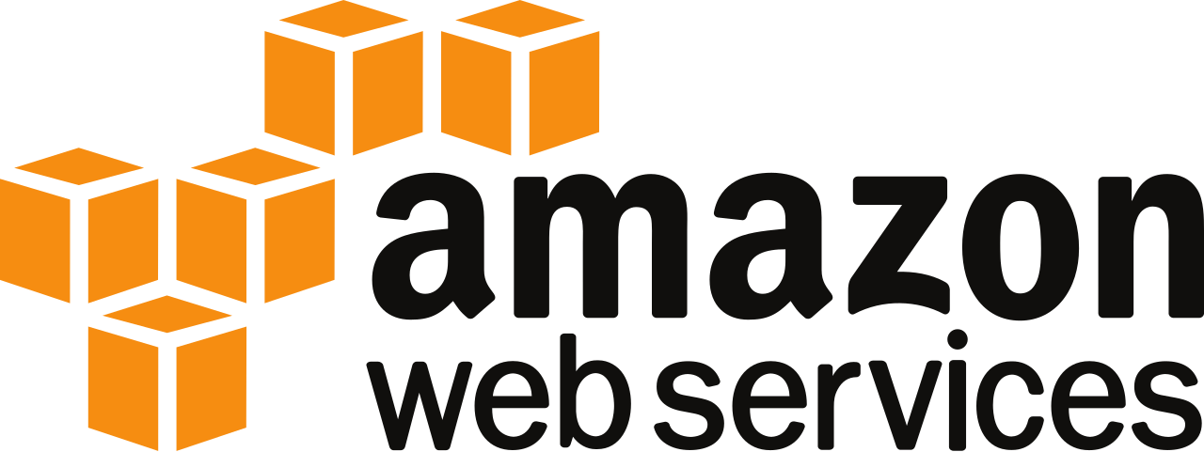

The AWS technology is implemented at [server farms](https://en.wikipedia.org/wiki/Server_farm) throughout the world, and maintained by the Amazon subsidiary. Fees are based on a combination of usage (known as a "Pay-as-you-go" model), hardware, operating system, software, or networking features chosen by the subscriber required [availability](https://en.wikipedia.org/wiki/Availability_(system)), [redundancy](https://en.wikipedia.org/wiki/Redundancy_(engineering)), [security](https://en.wikipedia.org/wiki/Computer_security), and service options. Subscribers can pay for a single virtual AWS computer, a dedicated physical computer, or clusters of either. As part of the subscription agreement,[[6]](https://en.wikipedia.org/wiki/Amazon_Web_Services#cite_note-AWSagreement-6) Amazon provides security for subscribers' systems. AWS operates from many global geographical regions including 6 in North America.[[7]](https://en.wikipedia.org/wiki/Amazon_Web_Services#cite_note-GlobalInfrastructure-7)

### **How AWS works?**

AWS operates on different services depending upon the user’s needs Services can be Storing databases, networking, security, analytics, etc. Amazon EC2 provides you virtual servers so that you can operate the system anytime you need. Amazon Elastic Block Store provides block level storage volume for data storage which you can apply on creation of an EC2 vm.

Amazon has a Simple Storage Service known as S3 which provides you data storage for backup or analytics.

AWS includes various tools and services designed to help users migrate applications, databases, servers and data onto its public cloud.

**Benefits of AWS**

[1. Ease of Use](https://sados.com/blog/aws-benefits-and-drawbacks/#1-Ease-of-Use)

[2. Incredibly Diverse Array of Tools](https://sados.com/blog/aws-benefits-and-drawbacks/#2-Incredibly-Diverse-Array-of-Tools)

[3. Unlimited Server Capacity](https://sados.com/blog/aws-benefits-and-drawbacks/#3-Unlimited-Server-Capacity)

[4. Reliable Encryption & Security](https://sados.com/blog/aws-benefits-and-drawbacks/#4-Reliable-Encryption-Security)

[4. Managed IT Services Are Available](https://sados.com/blog/aws-benefits-and-drawbacks/#4-Managed-IT-Services-Are-Available)

[5. AWS Offers Flexibility & Affordability](https://sados.com/blog/aws-benefits-and-drawbacks/#5-AWS-Offers-Flexibility-Affordability)

**Drawback of AWS**

1. Billing can be confusing
2. Amazon’s EC2 Limits
3. Common Cloud Computing Problems

**Azure (Microsoft Azure)**

**Microsoft Azure**, commonly referred to as **Azure**, is a [cloud computing](https://en.wikipedia.org/wiki/Cloud_computing) service created by [Microsoft](https://en.wikipedia.org/wiki/Microsoft) for building, testing, deploying, and managing applications and services through Microsoft-managed [data centers](https://en.wikipedia.org/wiki/Data_center). It provides [software as a service (SaaS)](https://en.wikipedia.org/wiki/Software_as_a_service), [platform as a service (PaaS)](https://en.wikipedia.org/wiki/Platform_as_a_service) and [infrastructure as a service (IaaS)](https://en.wikipedia.org/wiki/Infrastructure_as_a_service) and supports many different [programming languages](https://en.wikipedia.org/wiki/Programming_language), tools, and frameworks, including both Microsoft-specific and third-party software and systems.

Azure was announced in October 2008, started with codename "Project Red Dog", and released on February 1, 2010, as **Windows Azure** before being renamed to Microsoft Azure on March 25, 2014.



[Microsoft Azure](https://vimeo.com/264590480) is a cloud services catalogue which developers and IT professionals use to build, deploy and manage cloud applications through a global network of data centres which Microsoft has created for this purpose.

### **How Azure works?**

Azure uses a technology known as virtualization. Virtualization separates the close coupling between a computer’s CPU or server and its operating system by means of an abstraction layer called a hypervisor. The hypervisor emulates all the functions of a real computer or server and its CPU in a virtual machine. You can run multiple virtual machines at the same time and each virtual machine can run any compatible operating system such as Windows or Linux.

As other cloud services Azure uses a set of physical servers in one or several data centres that run virtualized hardware on behalf of clients.

Azure is an immense collection of servers and network hardware, together with a complex set of distributed applications which makes the configuration, the functioning of the virtualized hardware and these servers’ software. And this makes Azure efficient, users are now not responsible for maintaining and updating the hardware, as Azure takes care of all this in the background like AWS.

**Benefits of Azure**

1. Ability to Scale on Demand
2. Flexibility
3. Cost Competitive
4. Customer support
5. Hybrid Capability
6. Big Data insights
7. Simple and Reliable Data Storage
8. Keeping your Data Secure
9. Backups you can rely on
10. Integrative Data Solution
11. Automation

**Drawback of Azure**

1. Lack of Hyper-V Snapshot Support.
2. Inability to Upload Custom Images.
3. Provisioning Virtual Machines in the Cloud Takes Longer than On-Premise.
4. Lack of Integrated Backup.
5. Poor Management GUI and Tools.
6. No Access to Windows Client Images.

**GCP (Google Cloud Platform)**

**Google Cloud Platform** (**GCP**), offered by [Google](https://en.wikipedia.org/wiki/Google), is a suite of [cloud computing](https://en.wikipedia.org/wiki/Cloud_computing) services that runs on the same infrastructure that Google uses internally for its end-user products, such as [Google Search](https://en.wikipedia.org/wiki/Google_Search), [Gmail](https://en.wikipedia.org/wiki/Gmail) and [YouTube](https://en.wikipedia.org/wiki/YouTube). Alongside a set of management tools, it provides a series of modular cloud services including computing, [data storage](https://en.wikipedia.org/wiki/Computer_data_storage), [data analytics](https://en.wikipedia.org/wiki/Data_analysis) and [machine learning](https://en.wikipedia.org/wiki/Machine_learning). Registration requires a [credit card](https://en.wikipedia.org/wiki/Credit_card) or bank account details.

Google Cloud Platform provides [infrastructure as a service](https://en.wikipedia.org/wiki/Infrastructure_as_a_service), [platform as a service](https://en.wikipedia.org/wiki/Platform_as_a_service), and [serverless computing](https://en.wikipedia.org/wiki/Serverless_computing) environments.

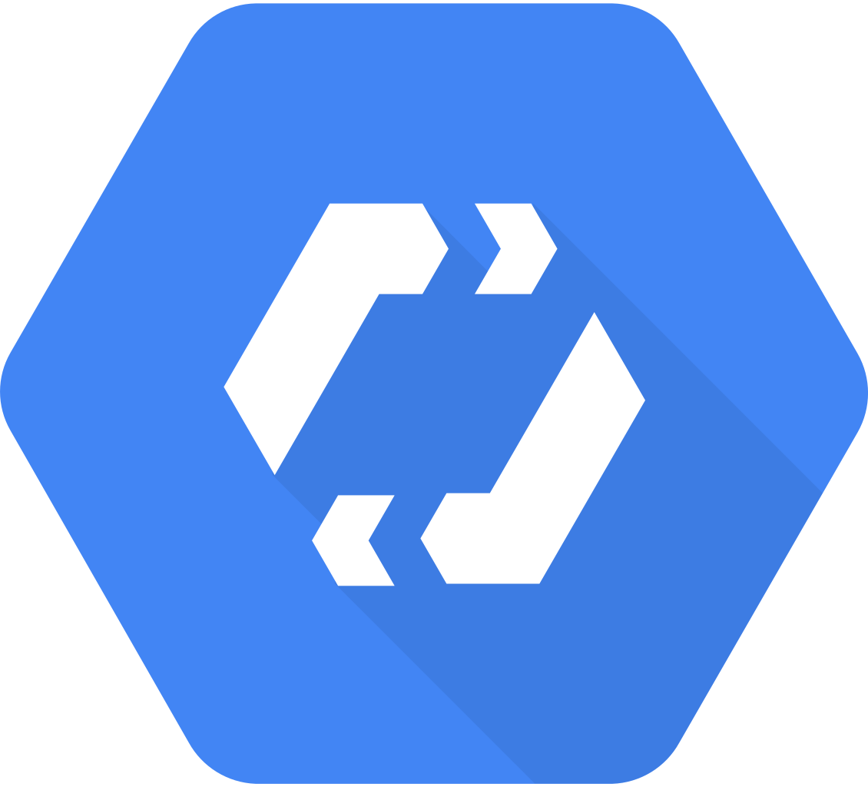

In April 2008, Google announced [App Engine](https://en.wikipedia.org/wiki/Google_App_Engine), a platform for developing and hosting web applications in Google-managed [data centers](https://en.wikipedia.org/wiki/Data_center), which was the first cloud computing service from the company. The service became generally available in November 2011. Since the announcement of the App Engine, Google added multiple cloud services to the platform.

Google Cloud Platform is a part  of **Google Cloud**, which includes the Google Cloud Platform public cloud infrastructure, as well as **G Suite**, enterprise versions of [Android](https://en.wikipedia.org/wiki/Android_(operating_system)) and [Chrome OS](https://en.wikipedia.org/wiki/Chrome_OS), and [application programming interfaces (APIs)](https://en.wikipedia.org/wiki/Application_programming_interface) for [machine learning](https://en.wikipedia.org/wiki/Machine_learning) and enterprise mapping services.

### **How GCP works?**

GCP provides a numerous features like other cloud services like :Compute Services, Storage Services, Networking, Big Data Services, Security and Identity Management, Management Tools, Cloud AI,etc.

Google uses Platform as a Service to deploy Java, PHP, and other applications.

It provides an online file storage web service for storing and accessing data.

It uses VPC (Virtual Private Cloud) ,CLB(Cloud Load Balancing) and CDN(Content Delivery Network for IP allocation , routing, distributing workloads on different users,etc.

Cloud IOT Core allows you to easily and securely connect, manage, and ingest data from devices that are connected to the Internet.

**Benefits of GCP**

1. Better Pricing Than Competitors.
2. Private Global **Fiber** Network.
3. Live Migration of Virtual Machines.
4. Improved Performance.
5. State of the Art **Security**.
6. Dedication to Continued Expansion.
7. Redundant Backups.

**Drawback of GCP**

1. Support
2. Documentation
3. Rate Of Innovation

## Now comes the Final point which one among the following AWS, Azure or GCP is best, Lets evaluate them taking different parameters as a cloud platform.

**Popularity:**

AWS is leading with around 30 percent of public cloud share ,on second place it comes Azure which owns 16 percent of worldwide market share and then comes GCP which owns 10 percent of market share worldwide.

**Services:**

IaaS- AWS uses Elastic Compute Cloud on the other hand Azure uses Virtual Machines and lastly GCP uses Google Compute engine.

paaS- Elastic Beanstalk is used by AWS, Azure makes use of App Service and Cloud Services and last Google App Engine is used by GCP for paaS services.

**Pricing:**

In the case of AWS, a very basic instance that includes 2 virtual CPUs and 8 GB of RAM will cost you around US$69 per month.

For the same type of instance, i.e., an instance with 2 vCPUs and 8 GB of RAM, in Azure, will cost you around US$70/month.

Compared to AWS, GCP will provide you the most basic instance, containing 2 virtual CPUs and 8 GB of RAM at a 25 percent cheaper rate. So, it will cost you around US$52/month.

## Availability:

* AWS has 66 availability zones with 12 more on the way.
* Azure has 54 regions worldwide and is available in 140 countries all around the world.
* Google Cloud Platform has been made available in 20 regions around the world with 3 more on their way.

**Conclusion:**

Now comparing all the features of these Cloud platforms we can conclude that among these three platforms AWS stands on first position.Some reasons for keeping AWS at top are better Market ,most popular, available in large areas.

Hence AWS is spread over a large geographical area ,it provides fastest access to data .